Happy Birthday…Your Majesty!
As you all know Her Majesty Queen Elizabeth II is 90 this year and there will be festivities during June to celebrate this remarkable achievement.
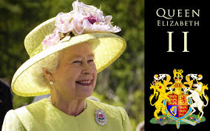
To help you support this event Blunsdon St Andrew Parish Council will be providing grants of up to £200. Please telephone Tracey Cole or Rachel Smith on 01793 705617 or e mail contact@blunsdonparishcouncil.co.uk for details of how you may be able to claim.

