APA 2021 REPORTS

BLUNSDON PARISH COUNCIL - ANNUAL PARISH ASSEMBLY 2021
FINANCIAL STATEMENT
2020/21
 | INCOME |  | EXPENDITURE
 | £ |  | £
General Reserves brought forward | 78,285
Precept | 90,000 |  | 0
Community Tax Grant | 1,779 |  | 0
Community Infrastructure Levy | 10,382 |  | 0
Burial Ground | 4,633 |  | 6,494
Recreation Areas | 500 |  | 7,122
Pavilion | 390 |  | 2,899
Parish Open Spaces | 0 |  | 15,208
Village Hall | 8,824 |  | 16,793
Methodist Hall | 0 |  | 31
Allotments | 805 |  | 0
Litter picking | 0 |  | 2,317
General Administration | 0 |  | 1,515
Staff costs | 0 |  | 62,536
Interest earned | 264 |  | 0
General Reserves carried forward |  |  | 80,947
 | 195,862 |  | 195,862
Reserved funds for specific projects |  |  | 117,536
(eg MUGA, Cemetery extension
works, fitness equipment)

Due to the Coronovirus lockdowns many of the Parish facilities were closed and considerable income was lost during the year.
The Parish Council applied to SBC for a grant and were fortunate to receive £10,000 to offset some of the losses and assist with increased health and safety measures.
Sadly the closure and subsequent sale of the Methodist Church buildings added to a reduction in income and the loss of the Council office.
No additional major projects, other than those funded by developers, have been planned for the forthcoming year in order to reduce the Precept needed and therefore the cost to the Council tax for our residents.
Rachel Smith,
Finance Officer.
Blunsdon Parish Police Report
Overview
Since 2016 Wiltshire Police has been following a Community Policing Team (CPT) Model which was a one team approach to Policing. Since that date the model has been continuously evaluated and developed.
From March 2019 having reviewed the model it was decided that the capacity for Neighbourhood Policing should be increased across Swindon and more officers allocated to specific areas in order to provide a response to community needs, whilst still working alongside CPT teams who cover the 24/7 policing need.

This has been true for North Rural villages. Blunsdon along with the other villages have PC Mandy Stevenson, PCSO Victoria Townsend, and PCSO Jo Bennett. (Currently maternity leave).
All supervised by PS Penny Sprawson.

These officers come under the North, East and Rural Neighbourhood team and are supported by Inspector Barry Reed, additional Police Sergeant, PS James Rodrigues, 5 other Police Constables and several other PCSO’s aligned to other specific areas.

PC Stevenson has been an officer with Wiltshire Police for just over 12 years. She worked as a frontline response officer for almost 10years before the CPT model began and has also had time working in the intelligence department as well as collating intel for the drugs team.
After returning from having her children she returned to working as a frontline officer for CPT, based in Swindon. Prior to joining in 2008 she was in the sport and recreation industry.

3mth Review:

We start by saying that Blunsdon is one of the safest areas of Swindon, with a very low crime rate.

February 2021 – May 2021
- There were 126 calls made to Police regarding incidents that have occurred within the beat-code for DN25 – Blunsdon.
- This includes people reporting Covid-19 breaches.
- Only 37 of these has had a requirement to be closed to the crime recording system.
- Blunsdon has seen 23 recorded incidents.
- Of which 14 were listed as crimes.
- A total of 57.9% of the calls made to Police were attended. The 40% not attended include duplicate calls, calls made to Police in error or persons being directed to the correct service. A high percentage of calls to the Police were for traffic incidents occurring on the A419, with other calls relating to COVID breaches which were attended by dedicated Covid-19 patrol officers. In comparison 12,720 logs were created for the whole of Swindon in the same time period.

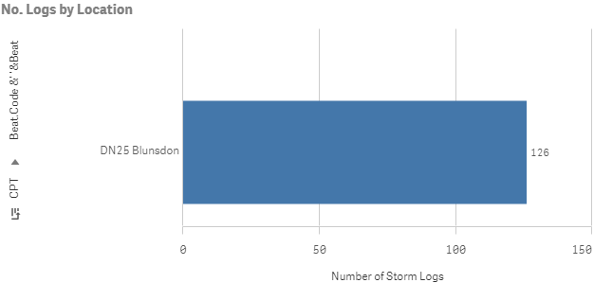
Number of Incidents
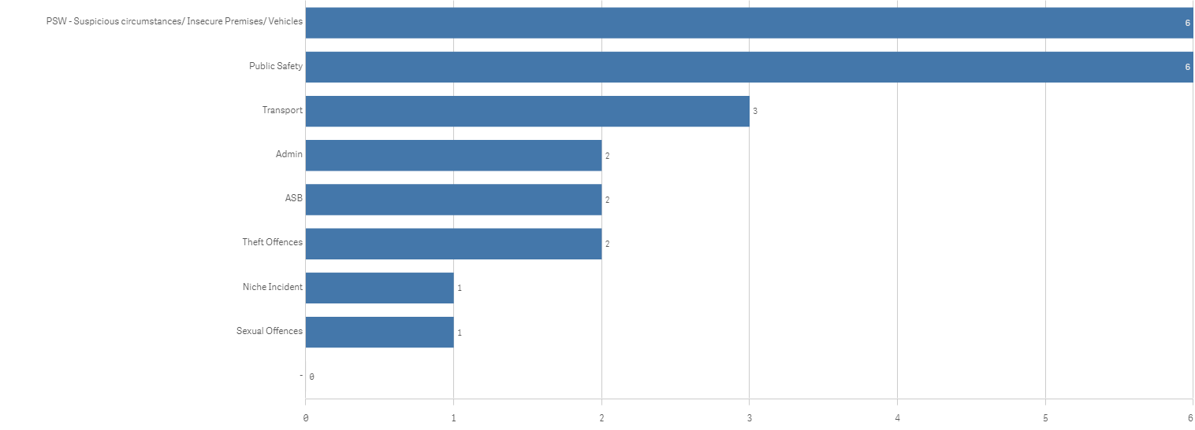

Crime Types:

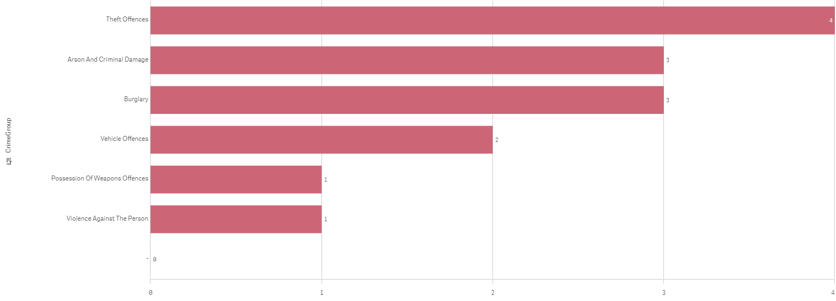

Crimes
- 14 crimes have been recorded for the Blunsdon area. Two of the burglaries are linked to commercial units on the Groundwell Industrial estate which is covered by the Blunsdon area. Several the thefts are linked to theft from motor vehicles in which several vehicles were left insecure.

Non Crime
- 23 recorded incidents.

- Many calls are for suspicious circumstances. These are reports of suspicious persons/vehicles in the area with no crime witnessed. Police have conducted an area search but not located anything of note.
(For noting the sexual offence listed below was created in error and has been non-crimed which is why it shows on this graph.)

Other News
Partnership working is increasing in relation to the landowners around the Blunsdon area. To provide patrols and to notify Police of any suspicious vehicles or events.
From this, increased regular patrols have been conducted on Little Rose Lane after numerous reports of large vehicles being driven down the track at the end of the lane.
Also, reports of poaching and hare coursing have been investigated, and additional patrols / support from the Rural Crime Team have been undertaken.

Blunsdon Nursery visit is being undertaken in the coming weeks for their Emergency services week.

We would urge anyone with any concerns or information about the area to make use of the online reporting facility or via 101 which is now free to call.

Alternatively email NERSCPT@wiltspolice.onmicrosoft.com The email address that goes to all the North, East and Rural Neighbourhood officers.
Lastly if you see any of our officers out and about please come and say hi and have a chat. Wiltshire Police wants to build a partnership working community. We look forward to seeing you.

Annual Parish Assembly – Chairman’s Report – Ian Jankinson
Coronavirus
In March 2020, in line with the published guidelines the Parish Council decided to take some decisions that will support the efforts to slow down the spread of the disease and protect the more vulnerable in the Parish.
- We suspended Parish Council meetings including the Annual Parish Assembly until further notice. As there is no guidance yet about the legality of video-conference meetings, we will take decisions on finance and planning using a safe voting in person system.
- We decided that from Monday 23rd March there would be no meetings/gatherings at the Village Hall, Methodist Hall or Pavilion, including gatherings on the Recreation Ground, except for the Pre School provision where we supported the guidelines issued for education settings.
- We will offer the 01793 705617 Parish telephone number as a ‘Helpline’ number for those in isolation who have no help or support elsewhere. Although we cannot guarantee help we will do our best to help where we can.
We worked closely with the Shop, which was a magnificent hub of support and continuity within the Parish and their cheery help and ‘Can do’ attitude was brilliant. I know that some of my Thursday Clap was for them.
Our Churchwarden Jane Ockwell also worked hard with our local congregation to ensure they were safe and well supplied where necessary. With these wonderful volunteers most of the gaps in the Parish were covered.
However there were still those that were hard to reach and support in the Parish. Residents kept a watchful eye out for those that might not be able to read the Magazine or access Broadcast Blunsdon or the Parish Facebook pages – or might not have been able to get to the Shop. Thank you to all of you who helped and there will be a celebration called ‘Brilliant Blunsdon’ in the Village on July 18th to celebrate our amazing community spirit.
Zoom Meetings
Because of all the restrictions associated with the pandemic, On Monday May 4th at 19:30 using Zoom, the Parish Council had its first ‘virtual’ full meeting. We have continued to do this until this month – May 2021 – as the temporary legislation allowing this expired and no further legislation has been put into place to resolve this. For absolute safety we have developed a ‘hybrid’ meeting structure – half Zoom and half Face-to-Face to ensure decisions are legal.
Frank Eggleton – 1932 - 2021

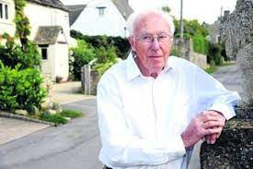
I am very sad to announce the death of one of the most influential Parish Chairmen that Blunsdon has ever had. He dedicated over 30 years to working for the Parish and left a legacy of respect and strength for the Parish Council in the Village. He dedicated decades to Parish Councils, chairing the Wiltshire Association of Local Councils and the South West Committee of the National Association, and serving on the NALC executive committee.

He was kind and generous and inspired me to join the council with his enthusiasm and vision even in his later years. There are many great stories that surround his tenure for which he will be remembered. He was active in the campaign to keep traffic away from the village and was a major influence in getting the by-pass built in 2009. He stood up for the Village at every opportunity and always did his utmost to keep Blunsdon rural and safe. I hope we can continue to maintain his vision, despite the pressures we are under, for now and the future.

Stuart Boyd

I am also sad to announce that after 23 years associated with the Parish Council, Stuart has decided to resign his position and not stand again for election. Stuart has been a stalwart supporter of the Parish and has contributed significantly to its success over the years. He and his extensive knowledge will be sadly missed although I am sure his presence will still be felt across the Parish despite his withdrawal. Good luck for the future and thank you Stuart for all you have done.
We still have an amazing crew of steadfast volunteer Parish Councillors who, with the tireless efforts of Tracey Judd, our Parish Clerk and Rachel Smith our Finance Officer, have smoothed out many of the ‘bumps’ during this unprecedented year. I cannot thank them enough for the work that they do, along with Mark Jones and Paul Schofield our Groundsmen, to keep this Parish looking good and working well despite restrictions and constantly changing parameters. Thank you all.
Parish Council Elections

May 6th 2021 was the date for this year’s PC elections. There are currently 11 positions available for Parish Councillors but there were more vacancies than nominations so all the people who were nominated were elected unopposed. Our elected Parish Councillors are:

Steve Ainscow Andrew Collingwood Mick Compton Stephen Doell

Ian Jankinson Sandra Keates Martin Nash Ian Selwood Jim Tayler
We still have vacancies so if you are interested please let Tracey know on 705617 or at contact@blunsdonparishcouncil.co.uk
Parish Council Office
With the proposed sale of the Methodist Church and Hall, the office finally closed on 26th October, however our contact details remained the same: Tel 01793 705617 and contact@blunsdonparishcouncil.co.uk .

Parish Council Meetings

The current legislation that allows Councils to have meetings and make decisions via virtual means (Zoom/Teams etc.) expires on the 7th May 2021 and the Government hasn’t allowed enough time to re-visit this legislation to be able to extend the law, therefore Meetings will have to be conducted face to face from then. MPs are putting a case for extension but as yet we have no positive news. This will not only affect our PC meetings but will curtail the numbers able to attend the Annual Parish Assembly on 20th May which we had to postpone last year. We will keep you posted.

Parish Responsibilities
Parish Council Finances
At our 4th January Meeting the PC voted for the Annual Budget for 2021/22 with approximately a 3% decrease to £77.52 per year for a Band D household. We decided that in these difficult times we would postpone several of the planned projects for this year and if relevant, carry them forward to next year. We have statutory expenditure, necessary expenditure and desirable expenditure and we will maintain a balance of these to keep costs as low as possible.
Blunsdon Village Magazine
The Magazine is a vital source of information and communication for the Parish and a lifeline to those not using the internet and social media. Early last year it was struggling to provide the magnificent service it has done, for much more than the 33 years I have been reading it. The Parish Council agreed to subsidise it to ensure its survival and was proud to help keep it going.
Blunsdon Methodist Church and Hall
The proposed sale of the Methodist Church and Hall was as much of a surprise for the Parish Council as it was for residents. The PC had registered the building as an Asset of Community Value and believed that the Methodist Circuit, who owns the property, would give us the opportunity to consult with the community to find out whether you wanted us to investigate ways in which it could stay in community ownership. In September we worked with North Swindon Scouts towards a possible solution where we may be able to keep the Methodist Hall as a Community Asset.
We put together a Consultation paper in the Magazine which outlined the potential cost to our Community should you decide that the Methodist Church and Hall should remain a Community Asset. The Consultation was also available on our Facebook Page, Broadcast Blunsdon and Website to vote on line via Survey Monkey.
There was massive support shown for the Community to save the lovely building and keep it in Community use. However, because of the level of investment required from the Parish Council and ultimately you, the residents, through your annual Precept, we had set a strong target for response to the consultation at 30% of households. In the final analysis of responses below, you can see that we only had an overall response of 13.2% of households, both through paper votes and on-line votes. Therefore we were unable to pursue the purchase of the Methodist Church and Hall, and could only endorse the potential bid from the North Swindon Scouts.
Responses:
- We had 41 paper responses, via post and the shop
  - 71% in support of bidding for the Church
  - 79% in support of endorsing the North Swindon Scouts bid
- There were 96 on line responses, broadly reflecting the paper responses
- There were 5 other responses
This meant that we received 142 responses from a base of 1,066 households in the Parish, representing 13.2%.
I was sad to have been informed by North Swindon Scouts that they were not in a position to bid for the Church and hall. So that means that the plot and buildings will now go on open sale and be lost to the community, such a shame.
Blunsdon Village Hall
In the meantime, the preparation of the other Village facilities as it became possible to bring them back into use was completed. All passed the Legionella test and were deep cleaned, ‘fogged’ and re-assessed in line with safety requirements and Covid 19 guidelines. All now have hand sanitisers and help signs to ensure safe use, and we have put together our own guide for users outlining what we will do and what will be expected of users going forward. These have been regularly updated as changes have occurred.
In MARCH we were offered some cycle racks and these will be fitted over the coming months. All cyclists will now be able to safely lock up your bikes while you visit the shop or Village Hall. We are fitting them at the Recreation Ground too.
Grounds Maintenance – Detailed report Ian Selwood – Vice Chairman
Apart from our GM Contractor who completes the majority of work in the parish we have two employees, Mark and Paul who support this work in a specific and targeted way to keep the Parish looking clean, well-maintained and safe. I would like to thank them for their contributions to making the Parish as beautiful as it is.
Play Areas
We now have 3 play areas to maintain in the Parish and as soon as the 5 outstanding developments are finished we will have 5 more play areas available across the Parish.
Multi Use Games Area (MUGA)
Money has been set aside over the years by developers around the Parish for the Parish Council to be able to develop the old Tennis Courts and grassed area behind them into a MUGA and cricket nets. We have been working with Swindon Borough Council for a long time, to try and move this forward however they have admitted that they do not have the capacity to do it. Therefore we have engaged a consultant to put a plan together to achieve planning permission. These areas will primarily be used by the school during the day and available to the local sports teams and public during the evenings. As the project moves forward we will share the progress with you with open exhibitions where you can share your ideas with us once we are allowed so to do.
Allotments
The Allotments in Hillside are working well and we are now working with Newland to set up more allotments in the Broad Blunsdon Heights development. One of these allotments has been designed with accessibility in mind
Planning
The PC has commented on 38 planning applications over the year as well as many Tree Preservation Orders.
In May of 2020 after persistent and continual lobbying of Highways England and Swindon Borough Council about the safety of the Turnpike Junction, Highways England requested that the Borough should delay any decisions on the several large outstanding planning applications for our Parish whilst they re-assess and re-model the Cold Harbour junction and the access on and off the A419. They acknowledged that the junction is carrying traffic above its design capacity, and they agree that at peak times the slip roads are high-risk areas due to queuing traffic.
Blunsdon East Neighbourhood Plan (BENP).
In MAY 2020 we received the Draft Report from the NP Examiner and she approved the Plan with some modifications and the Plan was modified to incorporate the suggested modifications. Then a proposal Paper went before a Full Borough Council meeting in July demonstrating that the NP met the Basic Conditions (national planning laws) with modifications as recommended by the Examiner. The Plan was unanimously approved and they made an agreement to hold the referendum in May this year, within the Parish. You as residents voted overwhelmingly in favour of the plan by 669 votes to 95, with a 45% turnout.
A reminder of the Major Benefits of the Plan:
- The Plan significantly will enable SBC Planning to enforce their Local Plan Policies, written to protect the Parish from unplanned developments. Which they are currently unable to do.
  - There are still applications for 460 houses and a church awaiting decision by SBC
- There are 12 robust Policies within the Plan, specifically designed to support our Community and preserve the Parish. These range from; improving road safety, protecting the countryside and green spaces and preserving the amazing views, to maintaining our ‘dark skies’.
- There are very detailed documents (Village Design Statement/Housing Character Assessments) available to the Planners to help maintain the character of the Parish
- Developer Contributions to the Community will increase from 15% to 25% which will allow us better scope to mitigate any development and improve infrastructure
- Ensuring a better relationship with those builders that are allowed to grow the Village.
Stagecoach Number 9 Bus – This service has now been re-routed through Blunsdon and will be stopping on Ermin Street in both directions on a circuit from Tadpole Garden Village to the town centre (in 25 minutes) and on to Wroughton. It runs every 30 minutes.
Parish Roads
We have regularly complained to SBC and developers in the Village about the condition of the road surfaces in High Street, Sams Lane and Broadbush during works that have taken place there. They both have acknowledged the complaints and have assured us that when work on the roads is finally completed they will be completely resurfaced.
Speed Watch.
Our fantastic volunteers have operated the Community Safety work of Speedwatch where they have been able, over the year. This work is invaluable to ensure that speeding is kept to a minimum on our Village roads. Offenders are sent warning letters for unsafely exceeding the speed limits and persistent offenders are visited by uniformed officers and cautioned – so beware! A massive thank you for all their hard and dedicated work.
Broadband Lower Speeds
We have worked with local SBCllrs and Justin Tomlinson during the year to try and get improvements to Broadband in the Village that is low speed. We have made contact with BT and Open Reach and are in negotiations with them to improve the service at a sensible cost to the residents – unfortunately it is a very slow process. (a bit like the Broadband!)
Village Fete 2020. Despite meticulous preparations and some magnificent organising by a brilliant group of Volunteers, the VE75 Village Fete had to be postponed and eventually cancelled. We still hope to hold this at some point in the future.
Best Kept Village Competition We enter this competition every year that we can and have won in the past. We have a good opportunity this year to better our 2nd place in 2018. It’s judged in May/June so time to get your bloomers in. We have already had offers of help and resources, from Village Groups and some developers so we are prepared to put up a good show this year – well certainly if the weather improves.
Plans for the future
Our first and most important priority is to work with the Borough Planning Authority to repel the outstanding planning applications for more mass housing in the Parish. The Neighbourhood Plan will help with that and there are elements within the Plan that we will now reinforce with actions.
The Recreation Ground and Pavilion are currently a project that we are working on. The Pavilion is a 70s building and not at all accessible. Our outline plan is to refurbish or rebuild the Pavilion and create an accessible ‘country path’ around the Recreation Ground to improve access to it, and build in some outdoor, accessible fitness equipment along the way.
We also have some funds to improve the landscape and safety along Blunsdon Hill and Ermin Street and are working with the Borough on how we might do that.
With the upcoming development in Kingsdown we can also look forward to some work to reduce the traffic and speed and improve the safety along Broadbush when the traffic is re-directed away from it.
We will also be planting more trees around the Parish in partnership with the Great Western Community Forest.
Ian Jankinson – Chairman Blunsdon Parish Council – May 2021.

Additional APA Reports May 2021

Grounds Maintenance:
Blunsdon is a semi-rural village location with a diverse mix of formal and rustic grassed and hedge areas. The PC has defined areas of responsibility to maintain certain grassed and hedged areas, beyond these the Borough Council and Highways England have reasonability (although we monitor and report on any issues as they arise).
Throughout the pandemic we have continued to maintain the estate, and it should be mentioned this was with the help, flexibility and cooperation of our contractors and staff.
During recent years we have focused on improving a number of hedge rows. This work has continued in areas such as the Rec Field and school footpath.
Additional clearance work has been completed in the area opposite the Methodist Hall and near to the old tennis courts. These areas have the potential to be enhanced further.
During the year the PC was handed back the previously mature hedgerow adjacent to Widhill lane from the developer Hills (+ the entrance area to the estate). The area has been replanted, but now needs time to recover and will be monitored ongoing.
The PC is aware of its environmental responsibilities and will consider a more balanced approach for some areas in terms of less grass mowing etc.to enhance habits.
The PC will continue to monitor our contractors to help ensure we provide a tidy & green village and provide best value within the financial budgets set. Additional projects will be considered to enhance the village further, where the budget allows.
Recreation Ground
The PC has reviewed the condition of our pavilion, that was originally constructed in the 1970’S. In summary it is not really fit for purpose in today’s world, and we are assessing the feasibility to replace the facility and improve accessibility.
The PC has worked with the Football and Cricket Clubs during the pandemic to agree the safest way to comply with government restrictions and provide safe sport where possible. The PC would like to note and thank the clubs for their excellent communication, help and cooperation during these challenging times.
We had extended conversations with the Football Clubs during the year to renew an aging terms agreement for the use of the facility. This included discussions and additional measures being agreed to help alleviate parking issues in Sutton Park for larger attendance games.
The PC considered extending the parking area off Sutton Park, but subsequently withdrew the consideration due to objections.

BVH & Cemetery
The PC has continued to manage the village hall during a very challenging time with many activities needing to be curtailed, or restricted.
We would like to thank our staff who had a considerable number of additional requirements to implement, to keep the facility clean and safe.
The PC has continued to manage and maintain the village cemetery.
Additional maintenance has included arranging for the cleaning of the war memorial and repairing the gate.
There is an extension to the burial area pending, as part of the adjacent Hayfield housing development. We will continue to leaise with the contractor to incorporate this with the existing area.
Footpaths
The PC does not have direct responsibility for footpath maintenance, this remains with the Borough Council.
We do understand the importance of our many footpaths to residents and continue to monitor and report on issues as they arise. This has included the area next to Blunsdon Hotel golf course (badger set damage) and the footpath adjacent to Longfield Farm (impassible due to mud & failing footbridge)

Councillor Ian Selwood
May 2021

